**A project reports**

**On**

**Online Book Store**

Submitted in partial fulfillment of the requirement of Project – III

(BCA278CO)

Of

Bachelor of Computer Application 4th Semester

**Submitted to**

Purbanchal University

Biratnagar, Nepal

**Submitted By**

Lenish Yesmali Magar

Puran Gupta

Manish Kumar Shrestha

**KANTIPUR CITY COLLEGE**

Putalisadak, Kathmandu

Aug 26, 2022

**A project reports**

**On**

**Online Book Store**

Submitted in partial fulfillment of the requirement of Project – III

(BCA278CO)

Of

Bachelor of Computer Application 4th Semester

**Submitted to**

Purbanchal University

Biratnagar, Nepal

**Submitted By**

Lenish Yesmali Magar (SymbolNo)

Puran Gupta

Manish Kumar Shrestha

**Project Supervisor**

Rubim Shrestha

**KANTIPUR CITY COLLEGE**

Putalisadak, Kathmandu

Aug 26, 2022

**CERTIFICATE OF APPROVAL**

This is to certify the project entitled “online bookstore” is a project work Submitted by

Lenish Yesmali Magar

Puran Gupta

Manish Kumar Shrestha

In fulfillment for the degree of Bachelor in computer application

………………….

Rubim Shrestha

Project Supervisor

Department of IT

………………….

Saroj Pandey

Head of Department

Department of IT

**ACKNOWLEGEMENT**

We express my deep gratitude and profound thanks to all individuals and institutions that have kind generously extended their support and help in accomplishing this project.

First of all, we would like to thanks Kantipur City College (KCC) for their peaceful working environment, lab facility and hardworking teachers who supported us and guided us during accomplishment of project.

We would like to Express my sincere gratitude to our programming teacher **Mr. Rubim Shrestha** for constant guidance, support, directions, suggestion and encouragements from the beginning of the study till its completion once again we would like to thanks for helping us to solve problem in the time when we were stuck in problems and couldn’t move any further. Due to complete activeness of our programming teacher, we were able to complete our project.

At last, but not least we owe a deep debt of gratitude to all those who helped me directly and indirectly and I would like to apologize if any names of helping had been not written. Without whom we would not have been successes in our project.

**Abstract**

The main objective of the project is to create an online book store that allows user to search and purchase a book online based on title, author and subject. The selected book is displayed in a tabular format and the user can order their books Using this Website the user can purchase a book online instead of going out to a book store and wasting time.

There are many on-line e book shops like Amazon which have been designed using Html. We develop similar website using HTML, CSS, JAVA script and PHP as front-end and MYSQL as a backend.

Online Book store is an online web application where the customer can purchase books online. Through a web browser the customers can search for a book by its title or author, later can add to the shopping cart and finally purchase using credit card transaction. The user can login using his account details or new customers can set up an account very quickly. They should give the details of their name, contact number and shipping address.

The Online Book Store Website provides customers with online shopping through a web browser. A customer can, create, sign in to his account, place items into a shopping cart and processed to check out.

The Administrator will have additional functionalities when compared to the common user. He can add, delete and update the book details, book categories, member information and also confirm a placed order.

.

Contents

Chapter 1: INTRODUCTION 1

1.1 Background 1

1.2 Purpose 1

1.3 Objective 1

1.4 Features 2

1.5 Assignment of roles and responsibilities 3

1.6 Documentation Organization 3

Chapter 2: Existing System 5

2.1 Pilgrims Book House 5

2.2 Pairavi Prakashan 5

Chapter 3 System Analysis 7

3.1 Functional Requirement 7

3.2 Nonfunctional Requirement 8

3.3 Feasibility Study: 9

3.3.1. Technical Feasibility 9

3.3.2. Operation Feasibility 9

3.3.3. Economic Feasibility 10

3.3.4. Legal & Ethical Feasibility 10

3.3.5. Motivational Feasibility 10

3.4 schedule 10

3.4.1 Gantt chart 10

Chapter 4: System Design 11

4.1 ER Diagram 11

4.2 Database Design 12

4.2.1 Database Tables 12

4.3 Activity Diagram 15

4.3.1 Activity Diagram for Admin module 15

4.3.2 Activity Diagram User side 16

4.3 Data Flow Diagram 17

4.3.1 Context Diagram 17

4.3.2 First Level DFD 17

4.4 Use case Diagram 18

4.5 Sequence Diagram 19

4.5.1 User login 19

4.5.2 Book Search 19

4.5.3 Add to shopping cart 20

4.5.4 Admin 20

Chapter 5: System Development and Implementation 21

5.1 Programming Platform 21

5.2 Operating Environment 21

5.2.1 Minimum requirement 21

5.2.2 Software and Hardware requirement 21

5.2.2.1 Software requirement 21

5.2.2.2 Hardware requirement 21

5.3 Testing plan 22

5.4 Featured to be tested 22

5.5 Testing tool 22

5.6 Test Cases 23

5.6.1 User 23

5.6.2 ADMIN 24

5.7 Implementation 25

Chapter 6: Conclusion limitation and future Enhancement 26

6.1 Conclusion 26

6.2 Limitation 26

6.3 Future enhancement 26

References 27

Appendices 28

**List of Figures**

Figure 1 Gantt chart 10

Figure 2 Er Diagram 11

Figure 3 Activity Diagram for Admin module 15

Figure 4 Activity Diagram User Module 16

Figure 5 Context Diagram of online book store 17

Figure 6 First Level DFD of online Book store 17

Figure 7 Use Case Diagram of online Book store 18

Figure 8 sequence Diagram of user Login 19

Figure 9 Sequence Diagram of book search 19

Figure 10 Sequence diagram of Add to Shopping cart 20

Figure 11 Sequence Diagram of Admin 20

Figure 12 User Interface Design of online book store 25

**List of Tables**

Table 1 Assignment Role and Responsibilities 3

Table 2 Documentation organization 4

Table 3 Functional Requirement 8

Table 4 User table of Database design 12

Table 5 Product table of Database Design 12

Table 6 order table of Database design 13

Table 7 Message table of Database Design 13

Table 8 Cart table of Database design 14

Table 9 Test case of user Registrations 23

Table 10 Test case of user login 23

Table 11 Test case of Add to cart 23

Table 12 Test case of Edit cart 24

Table 13 Test case of Admin add and delete book 24

Table 14 Test case of admin update book 24

Table 15 Test case of Admin manage order 24

Table 16 Test case of Admin manage user 25

# Chapter 1: INTRODUCTION

## 1.1 Background

An online book shop software program initiatives that act as a center database containing various book in inventory alongside with their title, writer and cost. This undertaking is a website that act as a center e book store. This web project is developed using HTML, CSS, JAVA script and PHP as a front end and SQL as a back-end. The SQL database store number of books related details. A user visiting the website can see the vast vary of books. The user may also pick out preferred books and view its price. The user can also search for particular books on the website. Once user select the book, he/she than has to fill the form and the book is booked for the user.

The software has following three main components:

1. Implement of new user to register and login
2. Implement user to choose any book.
3. Implement the user to buy book.

## 1.2 Purpose

For the project, we recommend to construct an online book shop for people. The online bookstore includes stories, study material, any course books like laptop be available to everyone. Many college students locate textbooks too steeply-priced to purchase at school bookstores and many publications solely use the required textbooks a few days in a semester This will become very wasteful and irritating for college students & others people. This on-line book place affords an answer to this. It will grant a service in which college students can purchase books on-line barring any treble. There will be free shipping. They do need to register with the web site in order to books. Payment information will be requested after including any numbers of books in the cart.

## 1.3 Objective

1. To provide service to distant area.

2. To save the time of user by providing book online.

## 1.4 Features

1. A home page with product Catalog
2. Search
3. Shopping cart
4. Admin login
5. **A Home page with product catalog**

This is the page where the user will be navigated after a successful login. it'll display all the book categories and will have a search keyword option to search for the required book. It also includes some special sections like latest product, featured product.

1. **Search**

A search by keyword option is provided to the user using a textbox. The keyword to be entered should be the book title or author name.

1. **Shopping cart**

The user can manage a shopping cart which will include all the books he/she selected. The user can edit, delete and update his shopping cart. A final shopping cart summary is displayed which includes all the items the user selected and the final total cost.

1. **Admin login**

The Administrator are going to be provided with special functionalities like

* Add or delete book
* Delete user
* Update book information

## 1.5 Assignment of roles and responsibilities

|  |  |  |
| --- | --- | --- |
| **Symbol NO.** | **Members** | **Role** |
|  | Lenish Yesmali Magar | Coding, designing and Documentation |
|  | Puran Gupta | Coding, designing and Documentation |
|  | Manish Kumar Shrestha | Coding, designing and Documentation |

Table 1 Assignment Role and Responsibilities

## 1.6 Documentation Organization

|  |  |  |
| --- | --- | --- |
| **Chapters** | **Heading** | **Content** |
| Chapter 1 | Introduction | * 1. Background   2. purpose   3. objective   4. features   5. Assignment role and responsibilities   6. Documentation Organization |
| Chapter 2 | Existing System | 2.1 Pilgrims Book House  2.2 Pairavi Prakashan |
| Chapter 3 | System Analysis | 3.1 Functional Requirement  3.2 Nonfunctional Requirement  3.3 Feasibility Study |
| Chapter 4 | System Design | 4.1 Er Diagram  4.2 Database Design  4.3 Activity Diagram  4.4 Data Flow diagram  4.5 Use case Diagram  4.6 Sequence diagram |
| Chapter 5 | System Development and implementation | 5.1 Programming platform  5.2 Operating environment  5.3 Testing plan  5.4 Featured to be Tested  5.5 Testing Tool  5.6 Test Cases  5.7 Implementation |
| Chapter 6 | Conclusion limitation and future Enhancement | 6.1 Conclusion  6.2 Limitation  6.3 Future Enhancement |

Table 2 Documentation organization

# Chapter 2: Existing System

## 2.1 Pilgrims Book House

**Introduction**

This book store has been in the Nepalese Market since 1984. The Specialty of this place is it provides some rare books which cannot be found in all of the Nepal. A part from providing several categories of book such as novels, comic books, graphic novel encyclopedia, dictionary, academic, journals, etc. the Pilgrims book house also sell maps, souvenirs, playing cards, small statues.

**Pros**

* Contain Nepali historical old books.
* Contain Audio Books.
* Contain Online payment method.
* International Shipping.

**Cons**

* Out dated user interface.
* Does not contain Search Filter.

## 2.2 Pairavi Prakashan

**Introduction**

This online book store sells books on categories such as an anthology, law, books for loksewa, comic books, children’s books, dictionary, magazine, Vedic literature, Yoga, Vaastu Shastra, and several more books that you can find in their online site. The books that are sold on the site are mostly written by local Nepalese writers who are masters in their crafts. Books are available in both English and Nepalese versions.

**Pros**

* Contains Books which are mostly written by local Nepalese writer.
* Contains Online payment method.

**Cons**

* Less books Categories.
* Out Dated User interface.

# Chapter 3 System Analysis

## 3.1 Functional Requirement

|  |  |  |
| --- | --- | --- |
| **No** | **Requirement** | **Functions** |
| R1 | Register | 1. The system shall allow non-registered user to create new account. 2. The system shall require the following information form the user, Name, Gmail, Password, confirm password. 3. The system shall confirm the username and password are accepted. 4. The system shall store the user information to the database. |
| R2 | Login | 1. The system shall allow registered user to login to their account. 2. The system shall require a user name and password for the user. 3. The system must verify the user’s name and password. |
| R3 | Search | 1. The system should allow user to search for books by title, author, book name, genre. |
| R4 | Shopping cart | 1. The system should allow user to add book to cart. 2. When viewing the shopping cart, the system shall display total price of the book. 3. When viewing the shopping cart, the system shall allow user to modify the shopping cart, i.e., increase/decrease book quantity, remove book form cart. |
| R5 | Check out | 1. The system shall allow registered user to purchase a book that are in there shopping cart. 2. The system shall require the following information form the user, name, Gmail, phone no, country, city, zip code. |
| R6 | Shipping Status | 1. The system shall allow registered user to view there shipping status of their order. |
| R7 | Logout | 1. The system shall allow the registered and logged-in user to exit form his/her account. |
| R8 | Dashboard | 1. The system shall allow admin to get access to dashboard. 2. When viewing the dashboard, the system shall display, total pending, complete payments, order placed, product added, users, admin user, total account and new message. 3. The system shall allow admin to add, remove or modify products. 4. The system shall allow admin to delete user. 5. The system shall allow admin to change order status of the user. |

Table 3 Functional Requirement

## 3.2 Nonfunctional Requirement

**Performance requirements:**

1. System login and logout shall take less the 5 second.
2. Search shall return the result within 10 second.
3. Order shall be processed within 10 second.
4. The system shall support multiple users simultaneously.

**Availability:**  
The bookstore should be available to user 24hr a day,7 days a week with the exception of being down for maintenance no more than 1 hour a week. If the system crashes it should be backup quickly.

**Security:**

User should be able to get access to only own personal information not others user.

**Easy to use:**

User be able to learn to use system very quickly.

should

## 3.3 Feasibility Study:

### 3.3.1. Technical Feasibility

We can strongly say that is technically feasible, since there will not be more difficulty in getting required resources for the development and maintaining the system as well. All the resources needed for the development of the software as well. All the resources needed for the development of the software as well as the maintenance of the same is available and we are utilizing the resources which are available already.

For design and development of the system, several software products have been accommodated. Database Design: MYSQL.

Coding: PHP, HTML, CSS, JavaScript.

Each of the technologies mentioned above are easily available. We have experience to use these technologies so it would be manageable to implement the project within the given time.

Therefore, the project is technically Feasible.

### 3.3.2. Operation Feasibility

Online book store will be GUI base web application. So that user will be able to easily understand the system and there will be no need for training. The system will help the user/customer to check the feature and price of the products by himself.

### 3.3.3. Economic Feasibility

Online Books store will be developed **Microsoft Visual code** and MySQL which are free to download. So, our project is economically feasible because the proposed system is very affordable. So, there is no issue related to development tools.

### 3.3.4. Legal & Ethical Feasibility

Our project does not violate any legality or any human rights. We own to develop online book store both legally and ethically. Data of public will be confidential. So, it is Legally and Ethical Feasible to complete this project.

### 3.3.5. Motivational Feasibility

Our team is highly motivated regarding this project and has very good problem-solving skill. Our project prompts to assign the task to every member of the group.

## 3.4 schedule

## 3.4.1 Gantt chart

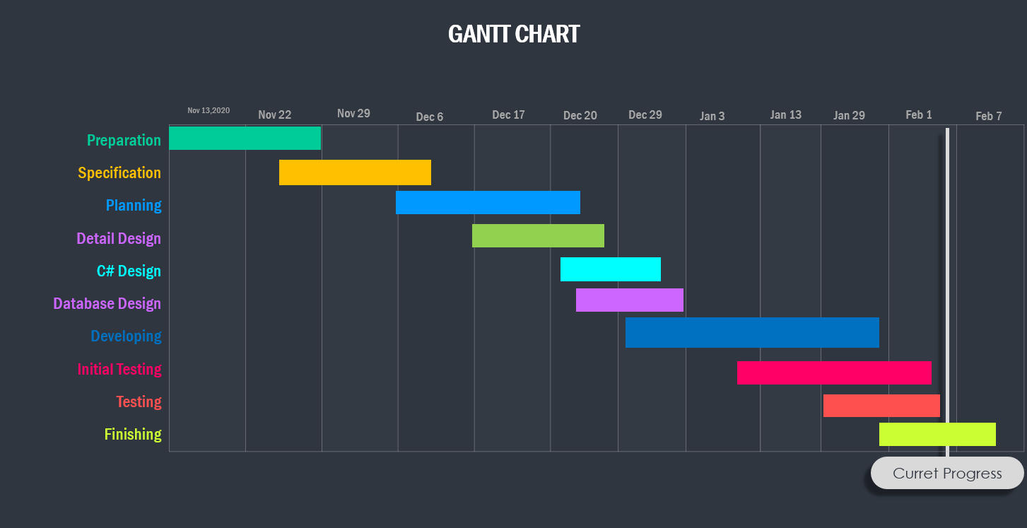

Figure 1 Gantt chart

# Chapter 4: System Design

## ER Diagram

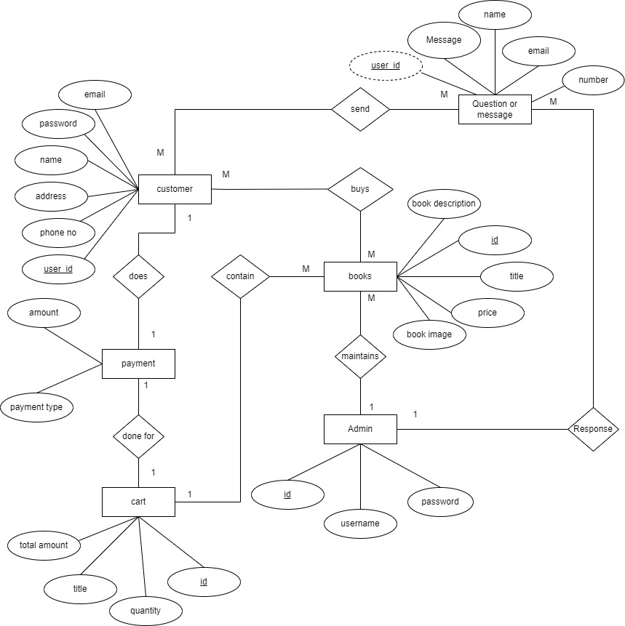

Figure 2 Er Diagram of online book store

## 4.2 Database Design

### 4.2.1 Database Tables

#### 3.2.1.1. User table

|  |  |  |  |  |  |
| --- | --- | --- | --- | --- | --- |
| Field Name | Data Type | Size | Allow Null | Extra | Constraint |
| User_id | Int | 100 | NO | Auto_Increment | PK |
| Name | Varchar | 100 | NO |  |  |
| Email | Varchar | 100 | NO |  |  |
| Password | Varchar | 100 | NO |  |  |
| User_type | Varchar | 20 | NO |  |  |

Table 4 User table of Database design

#### 4.2.1.2 Products

|  |  |  |  |  |  |
| --- | --- | --- | --- | --- | --- |
| Field Name | Data Type | Size | Allow Null | Extra | Constraint |
| Id | Int | 100 | NO | Auto_Increment | PK |
| Name | Varchar | 100 | NO |  |  |
| Price | BIGint | 100 | NO |  |  |
| Image | Varchar | 100 | NO |  |  |
| Product_desc | Varchar | 500 | NO |  |  |
| Author | Varchar | 40 | NO |  |  |
| Type | Varchar | 50 | NO |  |  |
| Genres | Varchar | 50 | NO |  |  |

Table 5 Product table of Database Design

#### 4.2.1.3 Orders

|  |  |  |  |  |  |
| --- | --- | --- | --- | --- | --- |
| Field Name | Data Type | Size | Allow Null | Extra | Constraint |
| Id | Int | 100 | NO | Auto_Increment | PK |
| User_id | Int | 100 | NO |  |  |
| Name | Varchar | 100 | NO |  |  |
| Email | Varchar | 100 | NO |  |  |
| Method | Varchar | 50 | NO |  |  |
| Address | Varchar | 50 | NO |  |  |
| Total_products | varchar | 1000 | NO |  |  |
| Total_Price | Int | 100 | NO |  |  |
| Placed_on | Varchar | 50 | NO |  |  |
| Payment_status | Varchar | 20 | NO |  |  |

Table 6 order table of Database design

#### 4.2.1.4 Message

|  |  |  |  |  |  |
| --- | --- | --- | --- | --- | --- |
| Field Name | Data Type | Size | Allow Null | Extra | Constraint |
| Id | Int | 100 | NO | Auto_Increment | PK |
| User_Id | Int | 100 | NO |  |  |
| Name | Varchar | 100 | NO |  |  |
| Email | Varchar | 100 | NO |  |  |
| Number | Varchar | 20 | NO |  |  |
| Message | Varchar | 500 | NO |  |  |

Table 7 Message table of Database Design

#### 4.2.1.5 Cart

|  |  |  |  |  |  |
| --- | --- | --- | --- | --- | --- |
| Field Name | Data Type | Size | Allow Null | Extra | Constraint |
| Id | Int | 100 | NO | Auto_Increment | PK |
| User_id | Int | 100 | NO |  |  |
| Name | Varchar | 100 | NO |  |  |
| Price | Int | 100 | NO |  |  |
| Quantity | Int | 100 | NO |  |  |
| Image | Varchar | 100 | NO |  |  |

Table 8 Cart table of Database design

## 4.3 Activity Diagram

### 4.3.1 Activity Diagram for Admin module

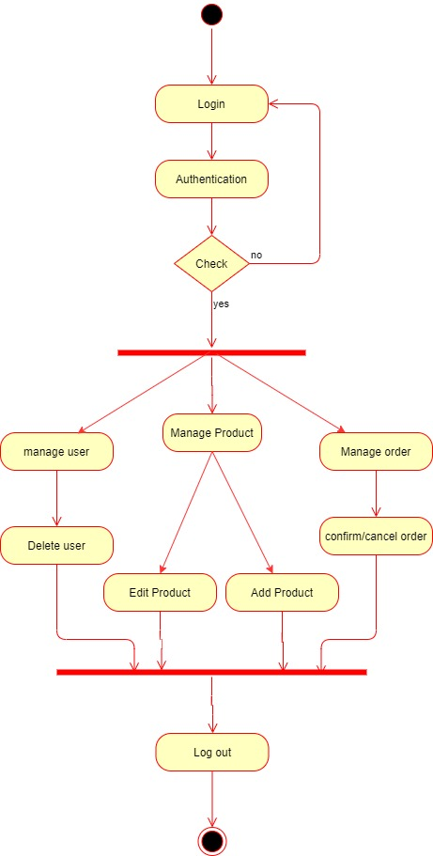

Figure 3 Activity Diagram for Admin module

### 4.3.2 Activity Diagram User side

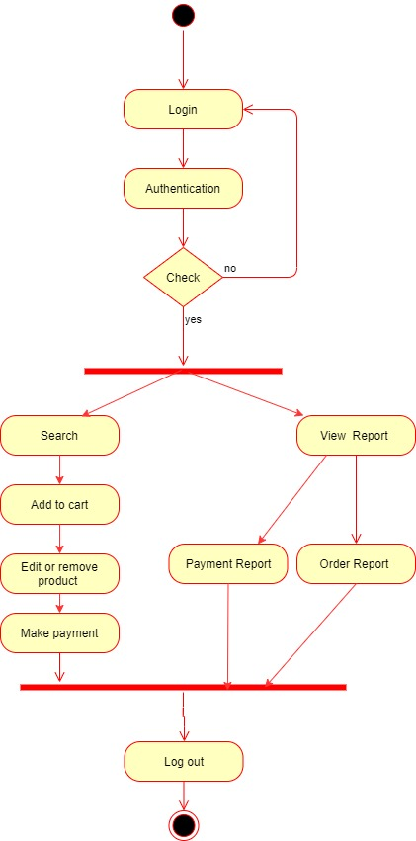

Figure 4 Activity Diagram User Module

## 4.3 Data Flow Diagram

### 4.3.1 Context Diagram

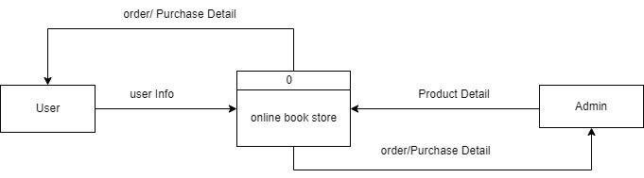

Figure 5 Context Diagram of online book store

### 4.3.2 First Level DFD

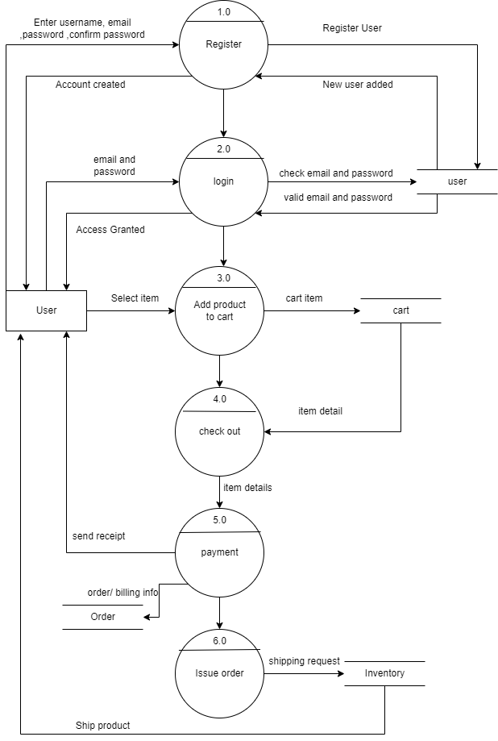

Figure 6 First Level DFD of online Book store

## 4.4 Use case Diagram

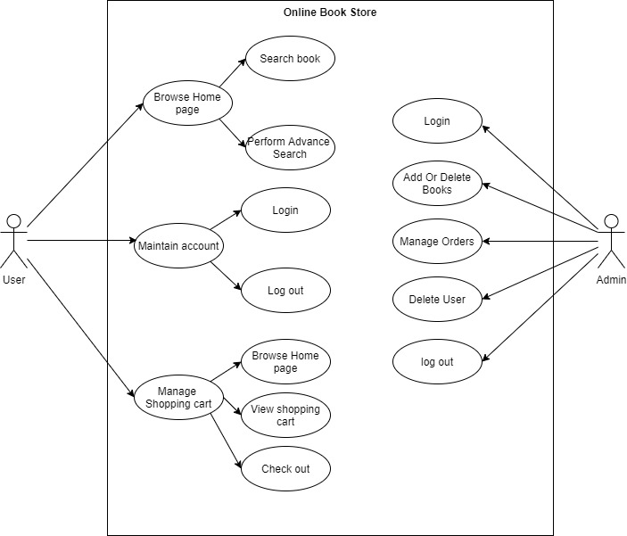

Figure 7 Use Case Diagram of online Book store

## 4.5 Sequence Diagram

### 4.5.1 User login

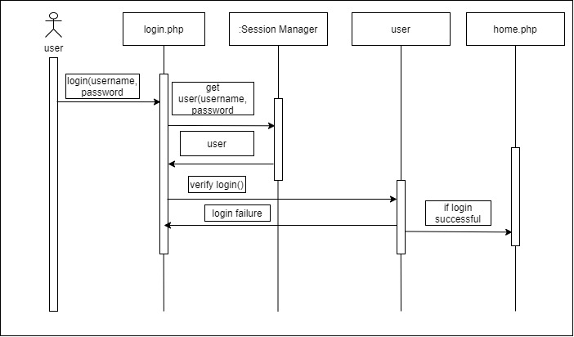

Figure 8 sequence Diagram of user Login

### 4.5.2 Book Search

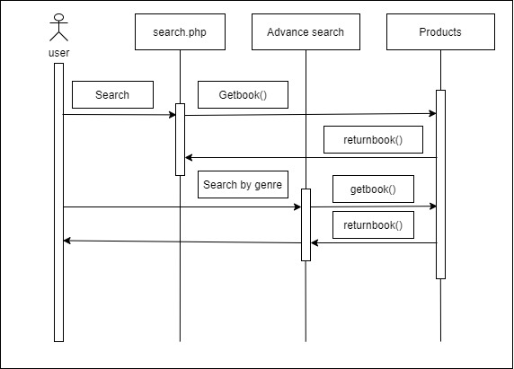

Figure 9 Sequence Diagram of book search

### 4.5.3 Add to shopping cart

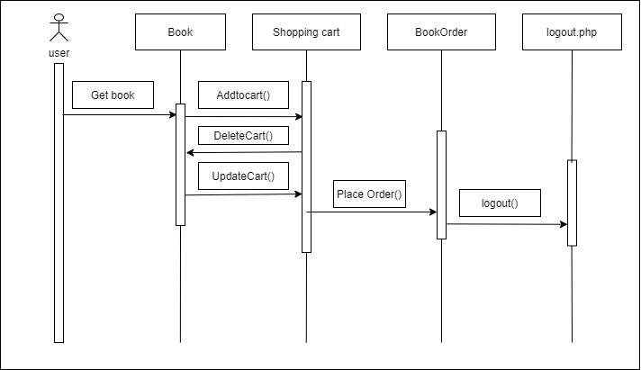

Figure 10 Sequence diagram of Add to Shopping cart

### 4.5.4 Admin

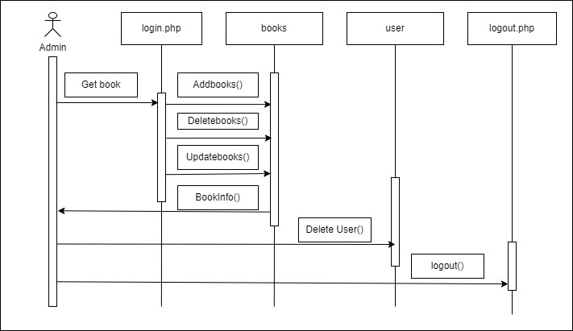

Figure 11 Sequence Diagram of Admin

# Chapter 5: System Development and Implementation

## 5.1 Programming Platform

This website is developed by using visual code tool and HTML, CSS, JAVA, PHP as a front end and MySQL database as a backend. We have used HTML, CSS, JAVA to design interface for our website and used PHP to connect with MySQL database. We have used MySQL database to store all the information related to Online Book Store.

This whole project is divided in to two modules.

* User module
* Admin module

## 5.2 Operating Environment

### 5.2.1 Minimum requirement

* Operating system- Window 7 or above
* MySQL database
* Visual code.
* Intel Core i3 or above.
* Ram 2GB or above.

### 5.2.2 Software and Hardware requirement

### 5.2.2.1 Software requirement

* Operating system- window 10 is used as an operating system.
* Xampp for MySQL.
* Visual code.

### 5.2.2.2 Hardware requirement

* Intel core i5 8th generation.
* Ram 8GB.

## 5.3 Testing plan

Since there are lots of interconnected components the team thoroughly tested the site to ensure that there is no problem. In additional to that website was tested on different size device as well as to ensure reactive nature of the website.

## 5.4 Featured to be tested

The following list describes the feature to be tested:

**USER:**

* Registration
* Login
* Add to card
* Edit cart

**ADMIN:**

* Add or delete book
* Update book
* Manage order
* Manage users

## 5.5 Testing tool

Testing was done manually to ensure there was proper co-ordination between the team members and was done by using GitHub. GitHub allowed for proper communication and provided with the progress of fellow team member to be noted, and also allowed for proper integration of the software.

## 5.6 Test Cases

### 5.6.1 User

**Registration**

|  |  |  |  |
| --- | --- | --- | --- |
| **ID** | **TEST CASE** | **USER INPUT** | **PASS CRITERIA** |
| U_REG_1 | User Registration | User enters different password in password confirm field. | Confirm Password Not Matched! |
| U_REG_2 | User Registration | User forgets to enter a particular required field. | Display message the value in field is required. |
| U_REG_2 | User Registration | User enters all the details Successfully. | User account created. |

Table 9 Test case of user Registrations  
**Login**

|  |  |  |  |
| --- | --- | --- | --- |
| **ID** | **TEST CASE** | **USER INPUT** | **PASS CRITERIA** |
| U_LOG_1 | User Login | User enters a wrong username | Display message Login or Password is incorrect. |
| U_LOG_2 | User Login | User enters a wrong password | Display message Login  or Password is incorrect. |
| U_LOG_3 | User Login | User enters correct username and password | User logs in successfully |

Table 10 Test case of user login

**Add to Cart**

|  |  |  |  |
| --- | --- | --- | --- |
| **ID** | **TEST CASE** | **USER INPUT** | **PASS CRITERIA** |
| U_AC_1 | Add to Cart | User selects a book and clicks add to cart button | Book is added to the shopping cart |
| U_AC_2 | Add to Cart | Guest selects a book and clicks add to cart button | User should create an account. |

Table 11 Test case of Add to cart

**Edit Cart**

|  |  |  |  |
| --- | --- | --- | --- |
| **ID** | **TEST CASE** | **USER INPUT** | **PASS CRITERIA** |
| U_EC_1 | Edit Cart | User changes the Quantity | Quantity and total cost of Cart should be updated. |
| U_EC_2 | Edit Cart | User deletes a book from shopping Cart | Books and total cost of Cart should be updated |
| U_EC_3 | Edit Cart | User selects a new book to shopping Cart | Books and total cost of Cart should be updated |

Table 12 Test case of Edit cart

### 5.6.2 ADMIN

**Add and delete book**

|  |  |  |  |
| --- | --- | --- | --- |
| **ID** | **TEST CASE** | **USER INPUT** | **PASS CRITERIA** |
| A_AD_1 | Add and delete book | Admin adds a new book | Books should be updated in product list. |
| A_AD_2 | Add and delete book | Admin deletes book | Books should be deleted form product list |

Table 13 Test case of Admin add and delete book

**Update book**

|  |  |  |  |
| --- | --- | --- | --- |
| **ID** | **TEST CASE** | **USER INPUT** | **PASS CRITERIA** |
| A_AD_1 | Update book | Admin update book | Books should be updated in product list. |

Table 14 Test case of admin update book

**Manage Order**

|  |  |  |  |
| --- | --- | --- | --- |
| **ID** | **TEST CASE** | **USER INPUT** | **PASS CRITERIA** |
| A_MO_1 | Manage Order | Admin change the state of order. | Order is completed |

Table 15 Test case of Admin manage order

**Manage Users**

|  |  |  |  |
| --- | --- | --- | --- |
| **ID** | **TEST CASE** | **USER INPUT** | **PASS CRITERIA** |
| A_MU_1 | Manage User | Admin Deletes user | User account is deleted |

Table 16 Test case of Admin manage user

## 5.7 Implementation

After multiple iterations with all the bugs eradicated finally the following windows was created.



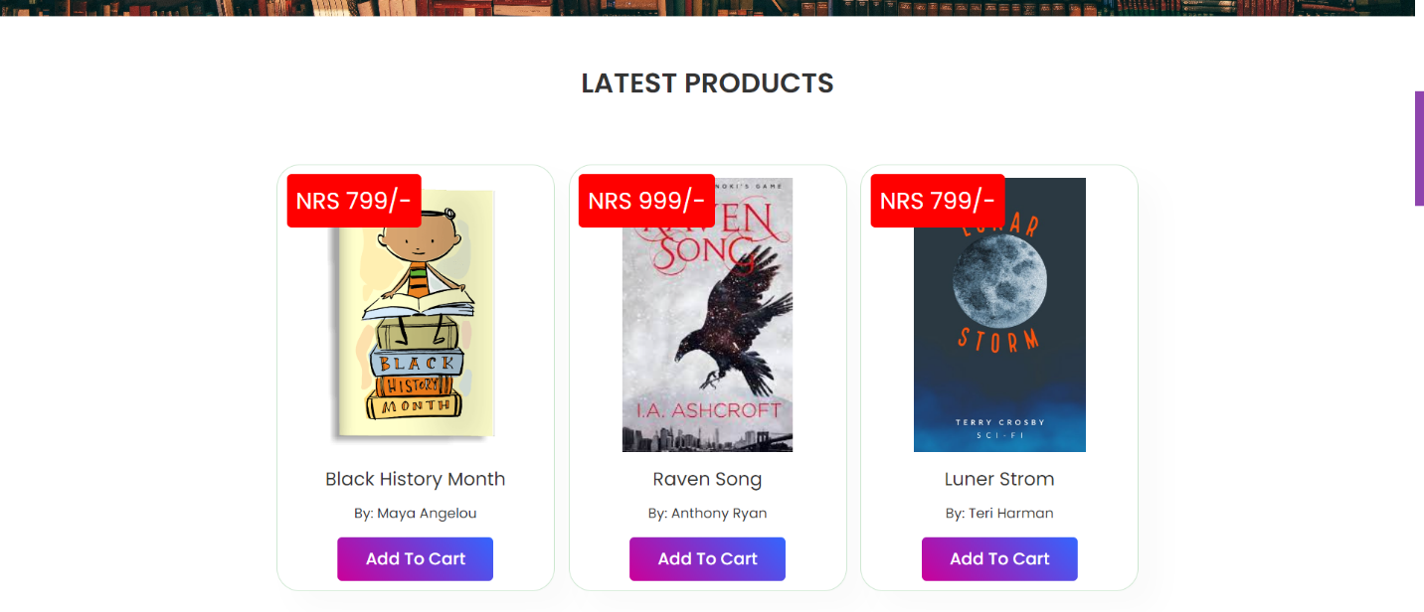

Figure 12 User Interface Design of online book store

# Chapter 6: Conclusion limitation and future Enhancement

## 6.1 Conclusion

Online book store is an online web application where the customer can purchase the book online. Through a web browser the customer can search book by its title, author or genres later can add to the shopping cart and finally purchase the book.

## 6.2 Limitation

* No online payment method.
* No hosting server.

## 6.3 Future enhancement

* Accept online payment method.
* Live server.

# References

Raman, R. &. (2013). Website development life cycle guidelines. 95-100

Kirkpatrick, Andrew et al. Web Accessibility: Web Standards and Regulatory Compliance, friends of ED, 2006..

# Appendices

**Home Page**





**Single Product Detail**

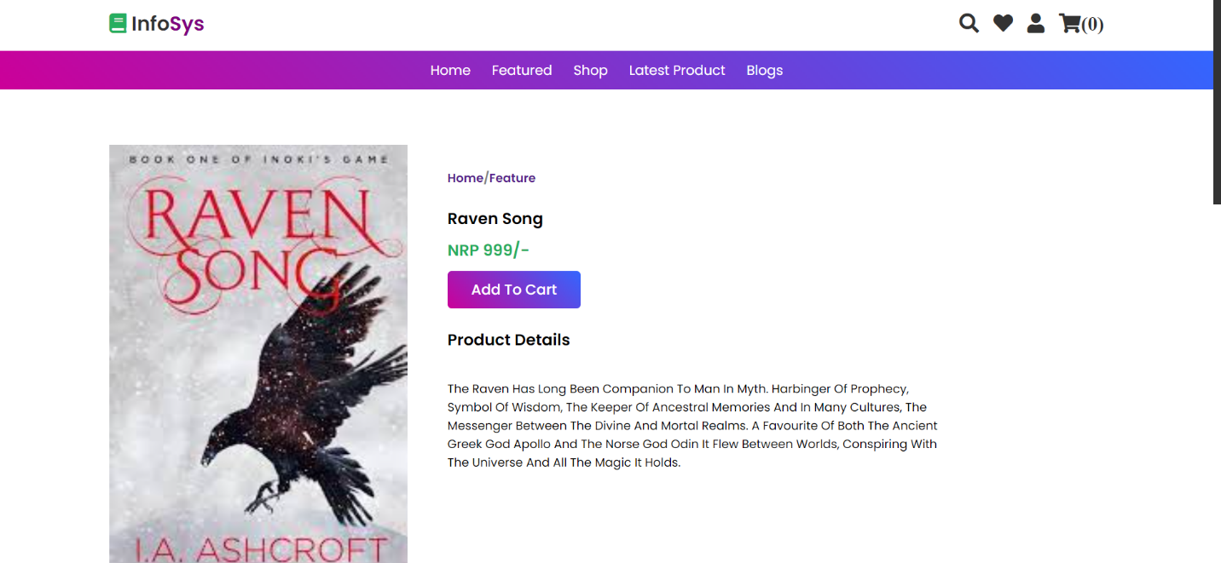

**Search**

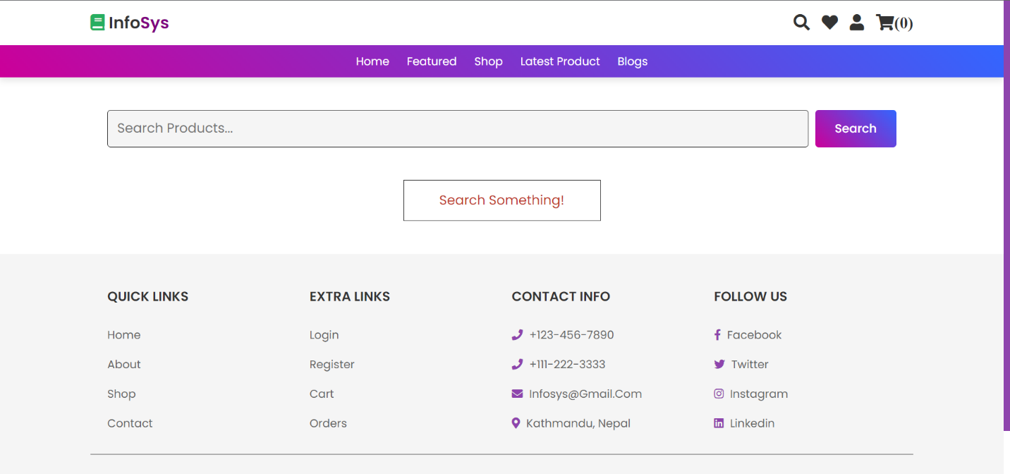

**Empty Shopping cart**

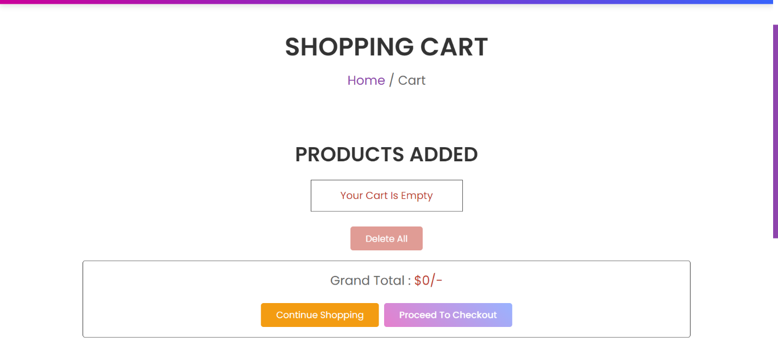

**Shopping cart with product**

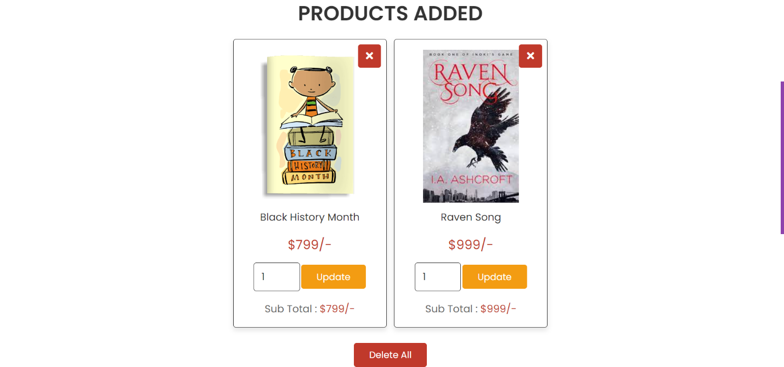

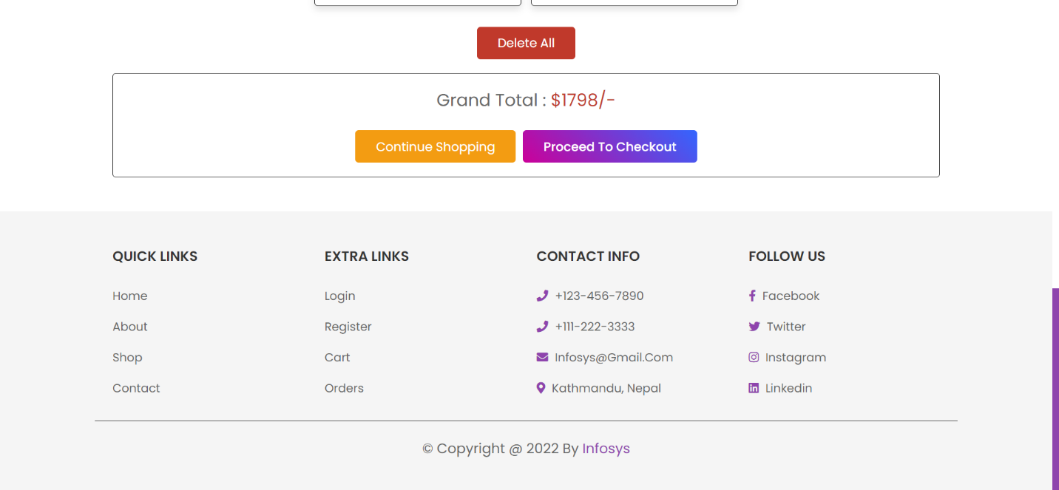

**Checkout**

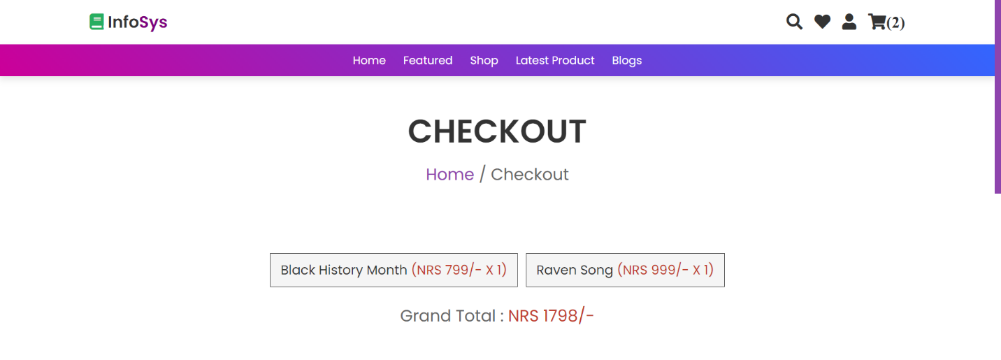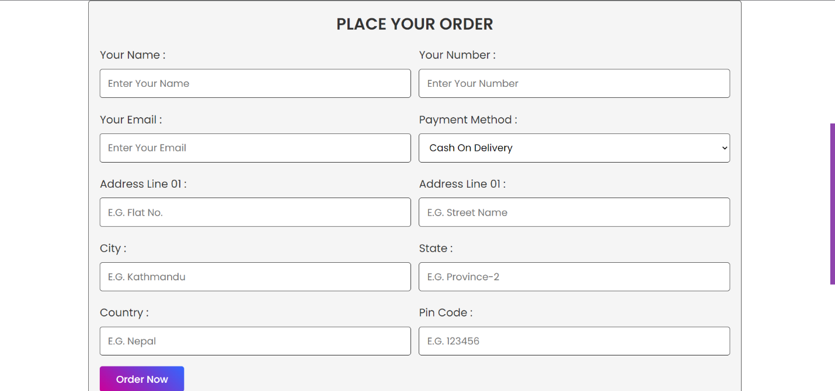

**Login**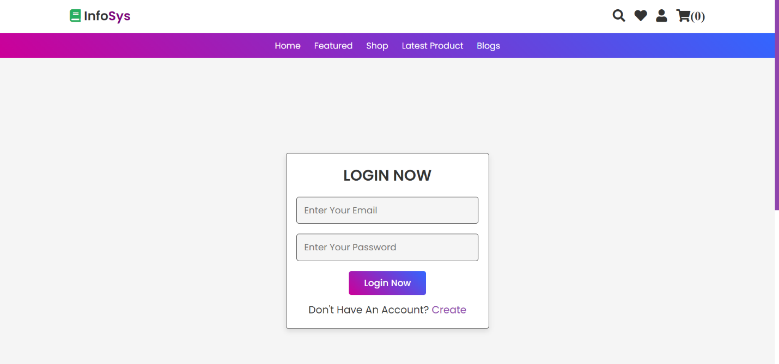

**Register**

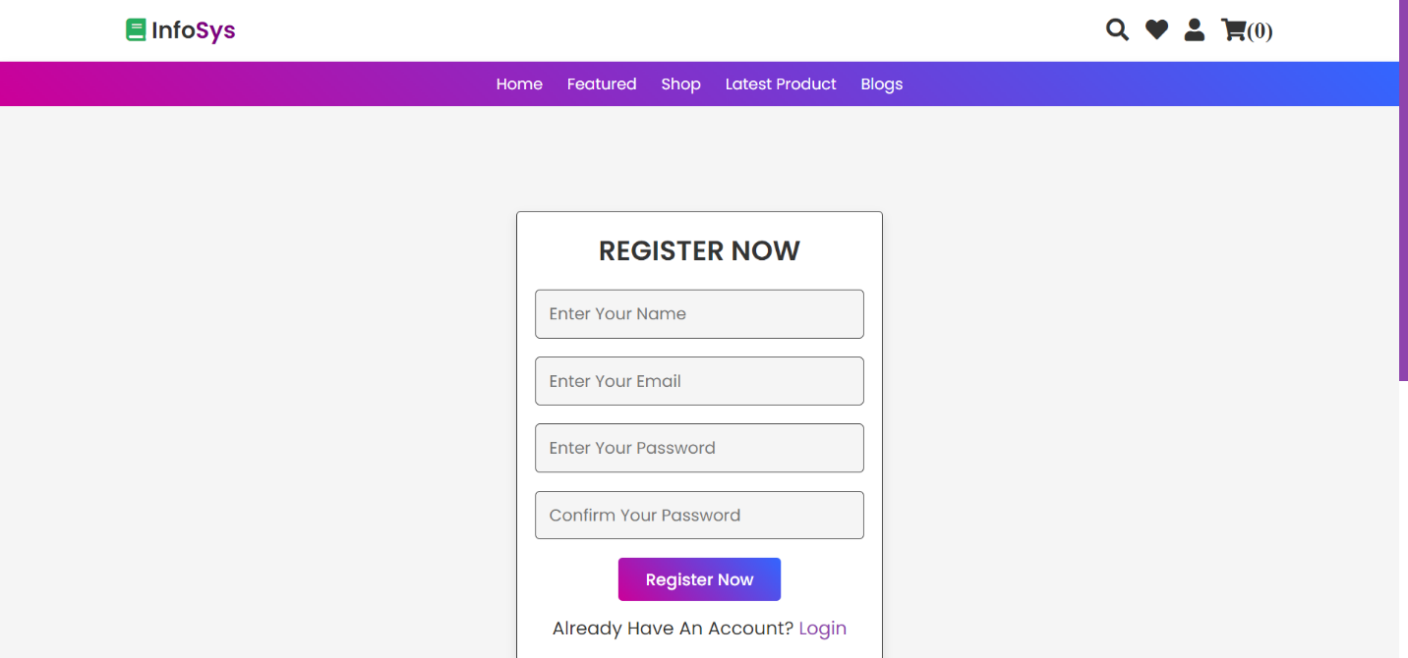

**User Profile**

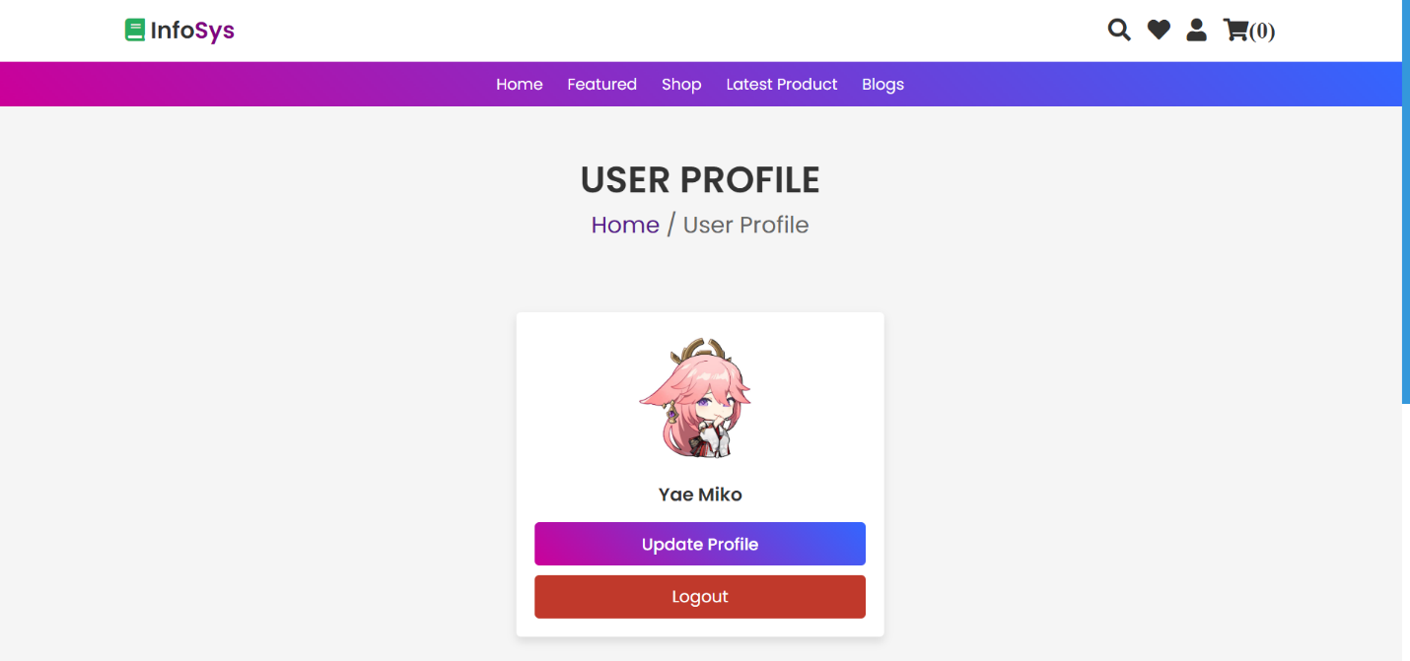

**Update user Profile**

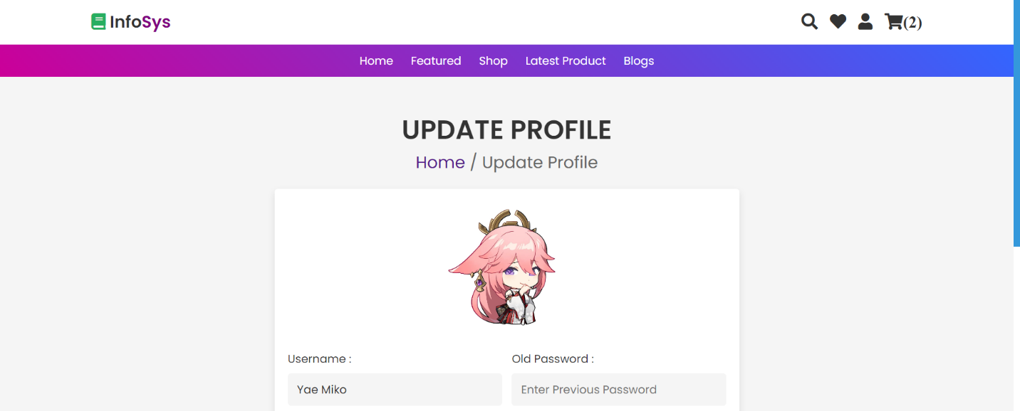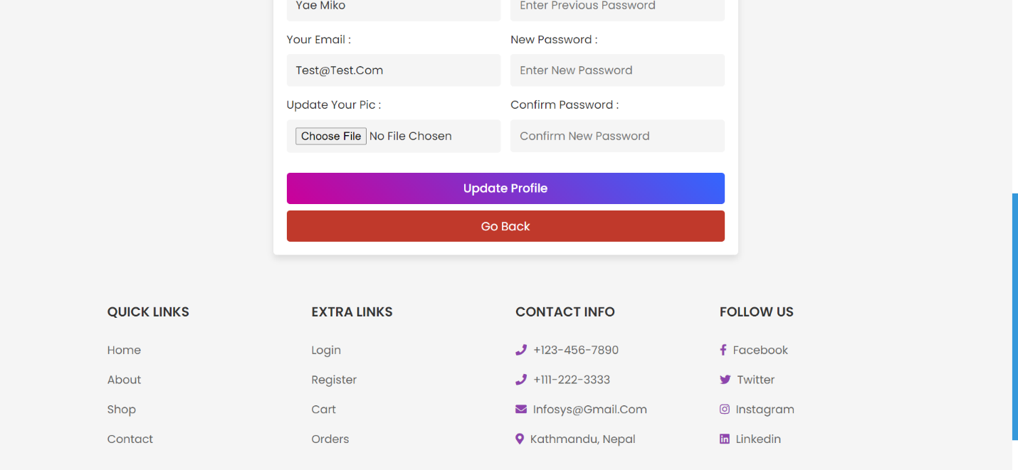

**Dashboard**

